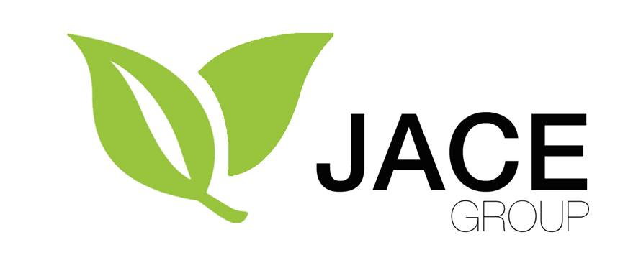
TERMS AND CONDITIONS

Services: The scope of the services to be provided to you shall be as set out in any written agreement signed by us. We are not responsible for providing any other services. By requesting us to provide services, you accept that our then current terms and conditions apply to you.

Price: The price specified for services shall be as set out in any written agreement signed by us. In the absence of any written agreement, the price for services shall be as determined by us. We may review our pricing from time to time by notifying you in writing. You may not withhold the price or deduct or set-off any amount against the price.

GST: Generally, we will quote prices exclusive of GST. Unless expressly stated otherwise in writing, you must pay GST in addition to the price.

Expenses: Unless agreed otherwise in writing, we may charge you for any expenses incurred in performing the services including (without limitation) the engagement of subcontractors, travel, materials, consumables and communications charges. We may charge you based on a reasonable estimate of our costs rather than actual costs incurred. We will not be obliged to incur any expenses on your behalf and may request payment of expenses in advance.

Payment: Unless we advise you to the contrary, any amounts payable to us shall be payable in full on the 20th day of the month following the date of our invoice. We may elect to suspend credit at any time (in our absolute discretion) and require payment in advance. We may stop supplying services if payment is not made in accordance with our payment requirements. If payment is not made in accordance with our payment requirements, we may elect to cancel an agreement with you by giving you 7 days notice of cancellation.

Guarantee: Where you are a company, if required by us, you shall procure that guarantees are provided by shareholders/directors to our satisfaction. This is an essential term of any contract with you and we are not obliged to provide services if this requirement is not met.

Materials/PPSA: Any materials supplied by us (including packaging materials), as detailed in invoices supplied to you, shall belong to us until such time as we are paid in full for those materials. We have a security interest in those materials and the proceeds of those materials and may take such steps as we see fit to protect our security interest, including registration on the Personal Property Securities Register. To the fullest extent permitted under the Personal Property Securities Act, you agree to waive your rights as debtor (including the right to receive a verification statement) and you and we agree to contract out of the debtor’s rights referred to in section 107 of the Act.

Default interest/costs: We may require that you pay us interest at 1.5% per month (or part month) on any amount due and unpaid. Payment of default interest is without prejudice to our other rights and remedies. If we take action to recover any amount due from you, or to otherwise protect our interests in relation to moneys owed by you, you agree to pay our costs (including debt collection and solicitor/client costs).

Timing: Any time specified for performance of the services is approximate only. Timing is not guaranteed.

Information/access: You will provide us with any information required for the purposes of performing the services in a timely manner. You must allow us access to your premises, personnel, facilities and equipment as reasonably required for performance of the services.

Agents/subcontractors: We may use agents to provide part of the services. Our agents and sub-contractors have the benefit of these terms and conditions including, without limitation, the provisions of the clause entitled “Our liability to you”. None of our agents or sub-contractors is authorised to make any representation or undertaking that contradicts these terms. We are not responsible for any misrepresentation made by any of our agents or sub-contractors with respect to our services.

Confidentiality: You agree to maintain as confidential the terms of any agreement entered into between us and any report or other information we give to you in the course of providing the services. We undertake to keep all commercially sensitive information that we obtain in carrying out the services confidential, except where disclosure is for the purposes of performing the services or with your consent.

Written advice/reports: Any written advice or report we prepare in the provision of the services is our intellectual property and we reserve the copyright in such written advice or report. You may not copy, distribute or sell the whole or any part of any written advice or report supplied by us without our consent. Any written report or advice prepared or supplied by us in the provision of the services is prepared for your use only. Any reliance placed on our advice or report by any party other than you is your responsibility and you agree to indemnify us accordingly. Any terms, conditions and/or disclaimers set out in any written advice or report provided by us to you shall be deemed to form part of the contract with you.

Non-exclusivity: We are entitled to provide services similar to those being provided to you to third parties as we see fit and nothing in these terms and conditions shall be construed as an exclusive arrangement between you and us.

Our liability to you:

We have no liability whatsoever in respect of:

the failure of any frost protection system to operate at all or to operate correctly; or

the outcome of any application of fertilisers or sprays to plants on your Orchard;

even where that failure or outcome arises due to an act or omission by us or our agent.

We are not liable for any delay or failure to perform services that arises directly or indirectly from an act of god, act of third party or any event or cause beyond our control.

You bear all risks in relation to Plant Pests. We are not liable for any damage or loss suffered by you (whether such damage or loss is suffered by way of damage to vines, structures or land, loss of income, fruit loss or otherwise) that arises directly or indirectly from any Plant Pest. This clause applies irrespective of whether we (or any agent) are directly or indirectly responsible for introduction of a Plant Pest.

We have no liability for a claim unless you notify us in writing with full details of the claim within 6 months after the end of the Season in which the claim arose.

Subject to paragraphs (a), (b), (c) and (d) above, and subject to any additional limitation of liability in any agreement between us, our liability shall be limited to liability suffered by you as a direct result of us (directly or via an agent):

breaching the express terms of a written agreement entered into with you; or

being negligent in connection with the services we provide to you,

but our total liability in any one Season shall be limited to a maximum amount of $10,000.

We are not liable in contract, tort (including negligence) or otherwise other than as set out in this clause 15.

All warranties implied by customary practice, at law or under statute are excluded to the extent legally permitted. The limitation of liability clauses in these terms shall be given a broad interpretation for our benefit (contra preferentum does not apply).

Notices: Notices or other communications to be given under any written agreement entered into between us must be in writing and served personally or sent to the address/communication point of the other party set out in the written agreement or as most recently notified by that other party.

Terms and conditions to prevail: These terms and conditions prevail over the terms of any agreement entered into between us except to the extent that a provision of a written agreement signed by us refers to specific clauses in these terms and conditions and states that the agreement shall prevail over those specific clauses.

Dispute Resolution: If either of us has any dispute with the other in connection with these terms and conditions or any of our Services the party that considers that there is a dispute shall promptly give full written particulars of the dispute to the other party and we shall meet together to try to resolve the dispute in good faith.

Amendment of terms: We may amend our terms and conditions from time to time by notifying you in writing (including by email). Any amendments to our terms and conditions will take effect from the date that we notify you.

Miscellaneous: In these terms, headings are used for convenience only and shall not affect the interpretation of any clause. No delay or failure by us to act or insist on any right shall be regarded as a waiver and every right remains enforceable and may be exercised by us at any time.

Definitions: (a) “Plant Pest” means any organism that has an adverse effect on kiwifruit, kiwifruit vines or the health or productivity of a kiwifruit orchard. The term Plant Pest includes (without limitation) viruses, bacteria, diseases, fungi, insects and other agents or conditions that may cause damage or adverse impacts on plants; (b) “Season” for the purposes of these terms and conditions means the period from 1 July in one year to 30 June in the following year; (c) “we” and “us” are references to whichever JACE entity is providing services to you, namely one of: Mount Pack & Cool Limited, Auckland Pack & Cool Limited, Southern Orchards Limited, Kiwi Green New Zealand Limited, Pure Pollen New Zealand Limited or other entities in the JACE group; (e) “agent” means an employee, sub-contractor, employee or agent acting on our behalf.

